7.3.8 Proceedings of the AranLIFE Conference 11th-12th September 2018

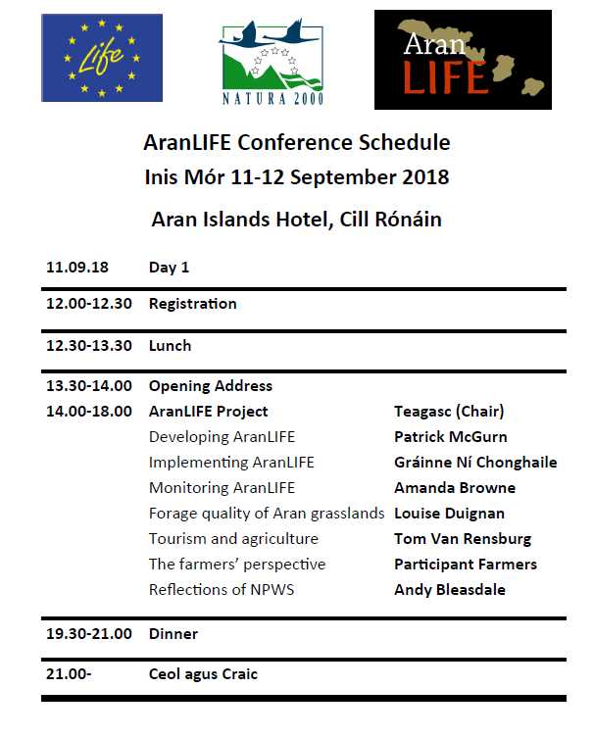

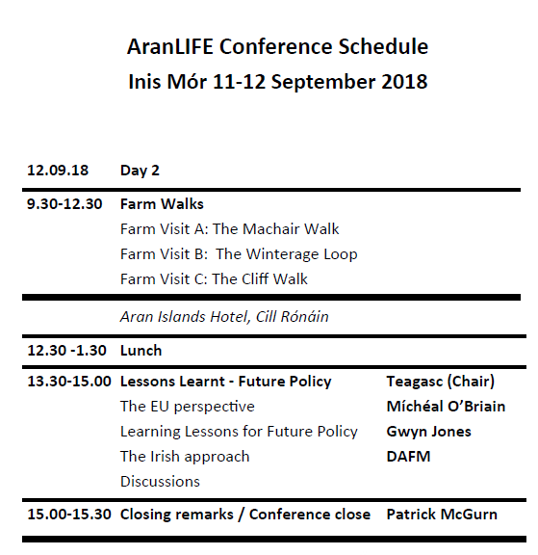
AranLIFE held a conference on the 11th and 12th of September 2018 in the Aran Island Hotel, Inis Mór. The conference detailed the AranLIFE approach in implementing a multi farmer programme in a high nature value farmland area which was locally led and incorporated a results based element. The project team and participant farmers outlined the works completed and overall findings. The talks detailed how the project came about and detailed how this locally led, results-based schemes approach could have a role in other High Nature Value farming areas.
On the second day there was a series of farm visits where examples of the completed works were visible and discussions facilitated among the participants on the project and its outputs. The conference concluded with a session on future policy and how the findings of AranLIFE could be incorporated into policy in similar High Nature Value areas both in an Irish and European context. The conference was an excellent opportunity to present the findings of AranLIFE to a wider audience as it included a range of interested individuals and groups including farmers from the islands and other High Nature Value farming areas, Government bodies including representatives from Northern Ireland, academic institutes, NGOs and media representatives.

Opening address Dr Aodhán Mac Cormaic.
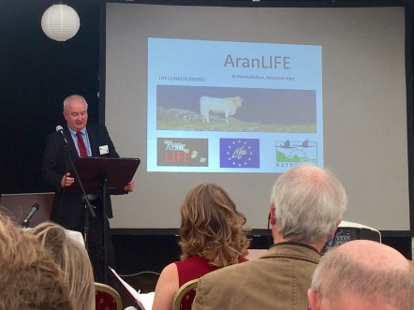
Dr Mac Cormaic highlighted how the islands are an integral part of Ireland’s heritage and the role of the Department is to ensure that sustainable vibrant communities continue to live on the islands. Agriculture on the Aran Islands is a central plank of this sustainability, not just in the food it produces but also in all the other services it supplies. Over 250,000 tourists visit the islands each year to take in the unique landscape and the magnificent flora maintained by the system of farming still practised on the islands. The islands are home to a range of habitats and plants rare in a European context and we have a moral duty as a nation to maintain them for ourselves and future generations.
DCHG was approached by a range of groups interested in developing a project for the islands that help solved some of the issues that had been identified by the farmers after a number of discussions. Whilst they had the ideas and identified funding they were having difficulty getting an organisation to co-ordinate the project, which is a requirement for a LIFE project. Despite difficult economic times, DCHG could see the potential in the project and therefore willing to step in and supply whatever technical, administration and financial help we could to make it happen.
The result was the AranLIFE project, a 2.5 million Euro project, 75% co-funded by the EU with the remainder of the funding from DCHG, Teagasc, DAFM, Fáilte Ireland, Heritage Council and Galway County Council. The diversity of these funders highlights that whilst they have different interests they recognise the importance of agriculture to the wider community, in terms of heritage, biodiversity, culture and tourism.
DCHG are pleased to see the progress with AranLIFE, the range of actions taking place on the ground, such as the removal of encroaching scrub, improving access, provision of water for the grazing cattle and also the quality of the information produced. Booklets on the islands wildlife, the newsletters and general communication through the media. The interest and enthusiasm of the project team and the participant farmers have led to a successful project and also given a framework to see how such projects can be developed and indeed how departments can support such actions in other areas.
DCHG are delighted to hear that the AranLIFE team were successful in putting together a successful application to the European Innovation Partnership and the department are happy to be involved as partners in the new project, Caomhnú Árann. DCHG we will work with the other partners, Teagasc, NPWS, Farmers and Fáilte Ireland offering any technical and financial (or administration) support we can to the new project so it can build on the success of AranLIFE and contribute to the next stages of the Rural Development plan to improve policy that recognises the importance of High Nature Value agriculture in maintaining much of Ireland’s biodiversity.
Dr Mac Cormaic thanked and acknowledged all the funders, The EU LIFE programme, Teagasc, DAFM, Fáilte Ireland, Heritage Council and Galway County Council, the steering group and project advisory group and the farmers of the island for their support and encouragement and the AranLIFE project team Patrick, Amanda, Gráinne and Louise for their hard work and enthusiasm in delivering the project.
(Translated from Irish)
Developing AranLIFE, Dr Patrick McGurn, AranLIFE Project Manager
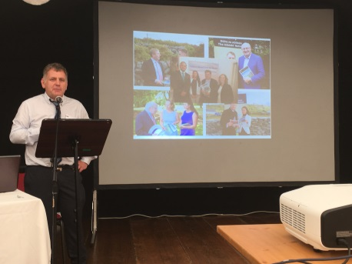
Dr Patrick McGurn, Project Manager of AranLIFE, spoke about how the project started. The Aran Islands have been known for their agricultural output. As far back as 1684 Ó Flaithbheartaigh wrote “Among these stones is very sweet pasture so that beef and mutton are better and earlier in season here than elsewhere; and of late there is plenty of cheese & tillage”. He explained how this is still the case with the island producing good quality beef cattle that are finished elsewhere in Ireland. Grazing occurs all year around with no housing or silage made, parts of the farm are grazed during the summer with the outer areas left ungrazed to supply a bank of grass for winter grazing. He explained how this agricultural system has an associated high nature value producing grassland habitats rich in wildflowers and other wildlife.
However poor economics returns from the agriculture system and limited room for expansion is changing the landscape of the islands, with lower grazing levels resulting in increase of scrub, leading to loss of grasslands and their associated flora.
Changes in the farm structure have been documented, for example the report from the Heritage Council in 2010 surveyed farmers and highlighted many of the issues. A post graduate report produced around the same period concluded that whilst existing agri-environment measures like REPS were positive for the islands they weren’t addressing the issues needed for the conservation of some of the habitats which had been designated under the EU Habitats directive because of their importance at a European scale. The Heritage council working with the European Forum for Nature Conservation and Pastoralism (EFNCP) worked with all the various stakeholders to develop a €2.5 million co-funded European project fund with DCHG, Teagasc, DAFM, Fáilte Ireland, Heritage Council and Galway County Council.
The project, called AranLIFE, was based on the Special Areas of Conservation (SAC) on the islands, covering three main habitats, Orchid rich calcareous grasslands (6210*), Limestone pavement (8240*)and Machair (21AO*), all priority habitats under the EU habitats directive and eligible for 75% funding through LIFE. The main areas for the project were:
• Working with farmers to improve the condition on a range of priority habitats
• Defining the characteristics of this High Nature Value farmland area
• Spreading the message of the importance of the habitats
• Linking tourism with agriculture
• Developing a results-based schemes that could be tailored for the islands and other high nature value farming areas which might not be fully served by existing agri-environment schemes.
• Feeding into future policy
To implement the project, a project team was hired consisting of a Project Manager (Dr Patrick McGurn), a Scientific and Technical Officer (Dr Amanda Browne) and Financial and Administration Officer (Gráinne Ní Chonghaile). Part of the work was also administered by Teagasc working with a Walsh Fellowship Student PhD student through the Institute of Technology, Sligo (Louise Duignan).
A series of meetings was held on each island and farmers were invited to submit an expression of interest, resulting in 101 expressions of interest from 220 farmers. Using selection criteria based on the suitability of the farm, 67 farms were selected.
Along with the farmer, a member of the project team walked the farm and agreed a works plan which was documented in a farm plan. The type of work included, improving access, removal of encroaching scrub from grasslands, provision of water holding features (raincatchers) either through fixing broken ones or building new ones and finally grazing, ensuring grazing levels were sufficient. The project didn’t dictate grazing times or grazing levels but held farm walks showing good examples and then developed a scoring system based on their quality. Its purpose was twofold, first of all to encourage adequate grazing and secondly to trial a result based programme which could be developed for future agri-environment programmes.
AranLIFE was a project dealing with agriculture and ecology and the team wanted to know more about the grasslands, what they contained, comparison with other areas, negative positive indicators and also what the yield and feeding value of the forage is, so this was an important aspect of the AranLIFE project. Based on the results and working with the local veterinary surgeon, the project looked at suitable feeding supplements to correct mineral deficiencies identified in the forage analysis.
Highlighting the biodiversity of the islands was also of the project. AranLIFE produced a range of booklets on the plants, butterflies and birds and historic monuments. These are aimed at farmers, islanders and tourists.
The project also looked at the link between farming and tourism, over 250,000 visit the islands every year and a major reason is the landscape and biodiversity which of course is maintained by the farming system. AranLIFE carried out a socio economic study interviewing tourists and farmers which Dr Tom Van Rensberg gave details on in his talk.
The AranLIFE approach has been successful, different interest groups came together as partners supplied advice, gave technical expertise, finance, to ensure successful outcomes both at the beginning of the project and continuing till the end. The approach trialled under AranLIFE can be tailored for other high nature value farming areas which might not be fully served by existing agri-environment schemes, particularly in relation to the new European Innovation Partnership programmes that have recently been approved within Ireland.
Presentation: Annex 7.3.8.1 E5 AranLIFE developing_Patrick McGurn
Implementing AranLIFE, Gráinne Ní Chonghaile
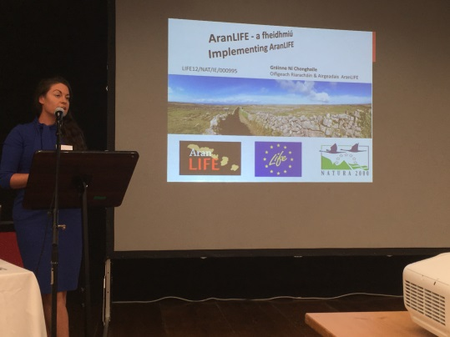
Gráinne Ní Chonghaile, Financial and Administration Officer explained how the project was implemented and the different steps taken by the AranLIFE team since the start which brought us to where we are today. It was not an easy task but it was successful due to the co-operation between the different stakeholders.
The farm plan approach was based on accurate mapping data which National Parks and Wildlife Service (NPWS) were able to provide. This gave us the farmed land parcels details, the SAC boundaries, historic monuments and some existing information on habitat types. Once we had that we could then map in all the different actions. Gráinne presented a working example from Inis Meáin showing how the size and costs of the work were calculated, the coding system used, for example clearance of light medium or heavy scrub, the system used for boreen clearance when improving access. After the farm visit identified the works required, it could then be mapped it, using this system with the areas and the costs involved calculated.
In regard to construction of raincatchers, the team worked with Galway County Council and NPWS, to ensure compliance with planning legislation and adherence to requirements under the Habitats Directive. New tanks were not possible within focal view-points (FVPs) without planning permission, so the mapping system used by AranLIFE allowed us to help comply with this. For the grazing action the project team scored each land parcel based on the quality of the habitat. These scores were then added as another layer within the mapping system and issued to the farmer along with advisory notes on improving the score.
A completed farm plan was presented and explained to the delegates at the conference. 67 farm plans were developed in less than 4 months by 3 members of staff which we considered as a good timeframe as in addition to the actual farm visits there was a huge amount of information to be transferred from the field to GIS – office – excel – publisher – to create a simpler / more accessible version to give to the farmers which could be more easily understood.
The Payment system was explained, farmers got paid for works completed. Once the work was completed the farmer sent in a claim forms, similar to an invoice and received payment after works inspected. The team found farmers were proud of the work and were happy to present the work completed.
In total the following works were completed
1. 28km of boreen improvements and 40 gates erected to assist with grazing management
2. 92ha scrub / bracken control
3. 107 tanks repaired and 103 new ones constructed.
4. Optimal grazing plans implemented on 1021ha.
5. Reduction in mineral deficiencies in livestock with the development of a suitable supplement which was based on forage sampling of the islands’ grasslands
6. Work instigated on 29ha of Machair habitat, including seaweed applications, rabbit control and survey work.
Whilst the project processes worked well there are ways of improving the overall administration. Gráinne highlighted some of the difficulties:
• Initial selection process led to a high work load, visiting every land parcel for selection and then again to draw up the farmplan, the highly fragmented farms, travel between the islands. The nature of island living means every task is more time-consuming, relying on weather which has a knock-on effect on work timetables.
• Individual farm plans worked well but the associated administration time is high.
• No specific software package for transferring information between GIS system to excel to a finished plan for the farmer, which increases the margin for error.

On the positive side
• Individual farmplan were good as each farm is different, ongoing communication with farmers, meetings, workshops, built relationships.
• Farm plans were simple so easy to understand, reduced paperwork
• Farmers liked the payments for specific works done approach
• Support from the various organisations.
• Increased farmer and public awareness of the importance of conserving these habitats through farming

AranLIFE shows that locally led projects can work successfully and could be modelled in other HNV areas, where generic agri-environment schemes cannot deliver, when based on the following principles:
• Regular farmer contact
• Organisational support: DCHG / Teagasc / NPWS
• Use of local knowledge and language
• Specific tailored software package
• Farmers preference for payment for works done
• Produce simpler, user-friendly plans/forms/payment process
• Don’t underestimate the level of administrative support needed.
(Translated from Irish)

Presentation: Annex 7.3.8.2 E5 AranLIFE implementing_Gráinne Ní Chonghaile

Monitoring AranLIFE, Dr Amanda Browne
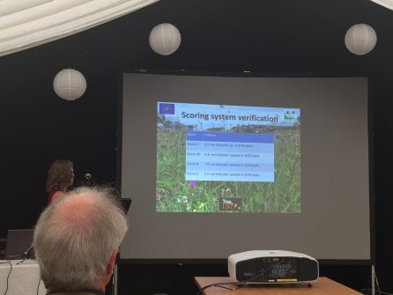
Dr Amanda Browne presented the monitoring approach within AranLIFE. Over 500 relevés were recorded covering a range of grassland types and condition and variations in farm management approaches. The work covered all aspects of monitoring, assessing impact of scrub control, verifying grazing score, monitoring the effects of seaweed applications and the impact of rabbit population on the Machair.
For assessing the scrub control, regrowth was recorded using transect with 1m² plots every 5m. The number of stems were counted and the percentage cover of target scrub species assessed within the transect. There was also a paired relevé within scrub patch and outside in ‘ideal’ vegetation for comparison purposes.
Monitoring the grazing impact also formed part of the work. This was based on developing a system whereby farmers get rewarded for the additional work involved, be it supplying extra cattle, building walls, better targeted grazing, all to improve habitat condition. Score 5 was the top score indicative of Priority habitat perceived to be very well managed, indicated by a high number of positive indicator species and an appropriate grazing regime (lacking indicators of undergrazing and overgrazing), down to score 2 which was semi-improved habitat with limited indicators of priority habitat, grass dominated, usually with higher levels of fertility or more recently made grasslands in an island context. These scores were allocated at a parcel level based on a walk through the field and noting different parameters. To ensure the scoring system was accurate ten 1m² plots were surveyed within each parcel and the presence of higher plants and dominant bryophytes was noted.
The monitoring showed fields with a higher score had the greater no. of indicator species. Using indicator species from The National list of indicator species used in the assessment of Calcareous grassland, some species ‘fit’ better than other species and are better indicator species for the Aran grasslands. This is a reflection of management, calcareous grassland across Ireland is managed different, the Burren has set stocking winterage grazing, the Aran Islands has rotational grazing during the winter, and Fermanagh limestone has all year round set stocking but mainly concentrated in summer. The monitoring indicated that past management should be considered more in national assessments particularly in relation to definition of positive and negative species.
Monitoring on the Machair grasslands looked at issues that needed to be addressed including; over dominance of bryophytes, (Rhytidiadelphus squarrosus in particular), impoverished Machair with inadequate forage for grazing and damaged areas with high areas of bare sand.
Application of seaweed had a positive effect on impoverished areas and areas of bare sand, seaweed supplied nutrients and organic matter which appeared both to hold water and bind the sand. However continued damage from rabbit grazing diluted the effectiveness of the work. 1m² rabbit exclusion cages were placed on areas where seaweed was applied and outside seaweed application sites to quantify impact of rabbits.
The results showed inside the cage, grass, broadleaf cover, height and yield were greater cage than outside while bryophyte cover was greater outside the cage, the plants recorded inside and outside the cage were similar. The rabbits are having a negative effect on the Machair and their control needs to be considered in Machair management plans.
AranLIFE is about the management of grasslands dependent on the farming system. The monitoring work added the scientific element to underpin the local expertise and knowledge. In doing so AranLIFE has collated the necessary data to provide information which has been used in the Best Practice Guides and Information sheets produced by AranLIFE.
Presentation: Annex 7.3.8.3 E5 AranLIFE monitoring_Amanda Browne
Forage quality of Aran Grasslands, Louise Duignan.
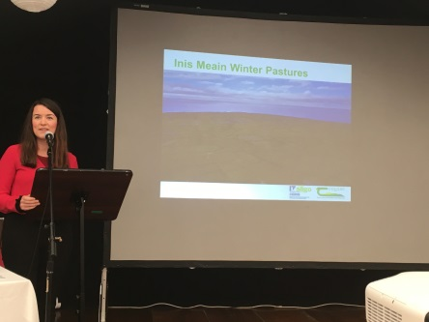
Louise Duignan, PhD researcher with the Institute of Technology, Sligo and Teagasc, presented details of the work she completed with the AranLIFE project. She first gave an outline of the farming and habitat types found on the islands and then the work involved to identify a sustainable grazing model suitable for the farming system on the islands. In this work she looked both to improve the agricultural production output by determining the feeding value of the grasslands and how best to achieve optimal grazing levels to maintain the species diversity. This was achieved through measuring the production of the different grassland types and recording present stocking rates involved along with species diversity.
Initially she instigated a sampling strategy to determine the different pasture types. Botanical surveys were carried out on over 50 sites and pastures with similar plant communities grouped together. From the analysis, two pasture types were dominant: summer pasture grazed throughout the summer months, and winter pasture, where a bank of summer-grown grass was established for grazing during the winter period.
The nutritional qualities of these pastures were measured. As the winter progressed the Crude Protein content declined whilst the fibre content increased. It was found that from approximately November to March the feeding value of the grasslands were below the nutritional requirements of the livestock. In addition Copper, Phosphorous and Selenium were deficient and some supplementation is necessary for good animal performance.
In terms of optimal grazing levels, above ground production of dry matter was measured using enclosure cages. The yield varied from 1-4.3 tDM/yr/ha on the winter pasture and between 4.5 and 6.7 tDM/ha/yr on the summer pasture. The most productive pasture (highest yielding) had the lowest species richness, whilst the highest species richness was found on the fields with lowest livestock carrying capacity.
Presentation: Annex 7.3.8.4 E5 AranLIFE Forage Quality_Louise Duignan
Tourism and Agriculture, Dr Tom Van Rensberg, NUIG
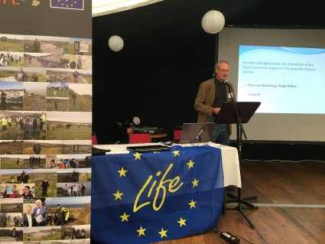
Analysis of farm finances via the National Farm Survey showed that farming on the islands was not capable of supplying an income equivalent to the average industrial wage and off farm employment where available was a major contributor to income. Many farm households have made significant investments in tourism and have become increasingly dependent on income from tourism. Tourism, agriculture and landscape are thus inextricably linked and farming underpins the Aran Island economy in two ways, through the sale of agricultural produce and by supporting the tourism economy through its landscape. Landscape externalities are therefore important in contributing to the future of the Aran Islands economy and development as well as to the welfare of individual households.
The studied examined the public good and tourism values associated with AranLIFE conservation actions using a valuation technique (Choice Experiments) to estimate the value of the positive externalities generated by the AranLIFE conservation actions using limestone landscape, orchid rich biodiversity. By surveying tourists visiting the island, it was found they placed a high value on the Aran Islands landscape and the landscape represents an important reason for their visit. The survey estimated, the aggregate benefits provided by the karst limestone pavements and the orchid rich biodiversity are in the region of €59 and €83 per hectare per year respectively. Therefore the positive Willingness To Pay (WTP) values stated by the respondents suggest that the Aran Islands landscape carries significant value and thus deserves to be well protected. From an economic perspective, AranLIFE project actions yielded a high rate of return on public investment (382%).
From the farm survey it was revealed that conservation actions involving in maintaining biodiversity orchid rich grasslands had a cost associated with it, and would requiring an annual payment of €160 per hectare to fully justify extra expense (extra time involved with sensitive management). Where the cost wasn’t available, it was likely farmers would intensify or reduce farming activity both affecting the ecological integrity of the site.
Presentation: Annex 7.3.8.5 E5 AranLIFE socio-economic impact_Tom Van Rensburg
The Farmers Prospective
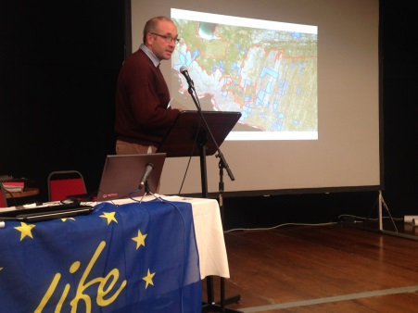
Domhnall Ó Flaithearta, Inis Mór, gave an overall view of his farm, made up of a mixture of limestone pavement and calcareous grassland and a mixture of the two. Basically the farm is split into two, summer grazing and winter grazing. No grazing occurs on the winter grazing during summer and then the standing crop is grazed in the winter so he doesn’t need cattle housing or make any silage.
Access is an issue on the farm due to so many dispersed land parcels, whilst the barna or stone gates may be a landscape feature when you have 150 fields it can be a lot of work so there is not as much target grazing as previous generations farming the land did. Part of the AranLIFE plan was about improving access on the narrow boreens that link different parts of his farm. He also cleared a lot of scrub, with hazel more common on his farm than briars and it all had to be cleared using hand tools. To improve the water situation he constructed new raincatchers, rebuilt broken ones and made use of some of the springs. All this work allowed more targeted grazing which improved the overall land both in appearance, animal performance and biodiversity. Part of the project involved looking at the performance of cattle on these grasslands and so there was a good opportunity to weigh calves and check animal performance.
Domhnall thought AranLIFE was positive for his farm, he liked the approach of working with the team, walking the farm with a member and jointly deciding what needed to be done. The farm plan approach was good as it outlined the work to be done, where it was to be done and the associated costs involved. (Translated from Irish)
Presentation: Annex 7.3.8.6 E5 AranLIFE Farmer 1_Domhnall Ó Flaithearta

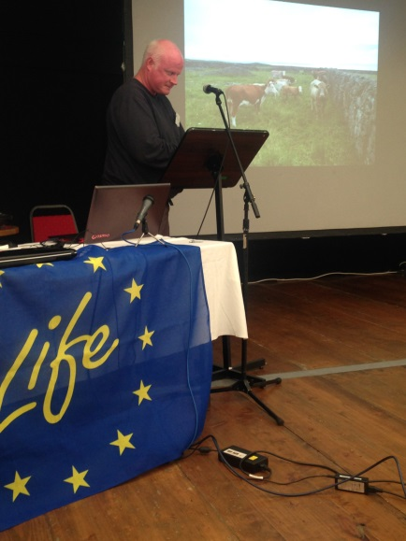
Pauraic Ó Coincheanainn, Inis Meáin, spoke about his farm which works on with his father Ruairí. The farm stretches from one end of Inis Meáin to the other made up of 31 different land parcels and about 90 different fields. For a variety of reasons the farm had started to scrub up a bit mainly due to lack of time but also because of water issues. With no rivers on the island, water for livestock is a problem and often the cost of replacing a raincatcher isn’t worth the return in terms of extra grazing from a field. So replacing and building new raincatchers was a major part of the AranLIFE plan for his farm.
This wasn’t that easy to do as fields that needed water were in the more inaccessible areas and blocks and sand had to be carried over long distances. It got too labour intensive to carry them so they reverted back to an old bit of technology that hadn’t been used for a while, a donkey with baskets. Even with that there was a lot of wall rebuilding as he had to knock walls down for access. Traditionally these were built as bearna (stone gaps) but with 90 fields that’s a lot of time so as part of the project he put in a number of gates to help with management, blending them in using stone pillars. He also increased cattle to improve grazing. The AranLIFE project supplied weighing facilities so he can record performance and is happy with the results.
The farm contains Machair, which he explained looks good from a distance but doesn’t grow much grass so as part of the AranLIFE project he applied seaweed to the most impoverished areas and the project monitored the results, and for him the results were quite dramatic. He was happy with what was achieved with the project on his farm and thinks it benefited the islands and the farm has improved in terms of agricultural and biodiversity and his interest has increased in both farming and biodiversity. (Translated from Irish)
Presentation: Annex 7.3.8.7 E5 AranLIFE Farmer 2_Páraic Ó Coincheanainn
Tomás Ó Conghaile, Inis Oírr told the conference about his farm which is basically a strip from the front of the island to the back. It is less fragmented than many farms on the islands, but still has 8 different land parcels and 49 fields making up over 8 hectares.
He produces suckler calves that are bought by dealers coming from the mainland for finishing elsewhere. But the way he produces the calves also means he produces species rich grasslands but the calves pay better. A lot of the land has been made relatively recently, with Inis Oírr having higher population and more sand, land making probably went on a bit later but he still has the limestone pavement mosaic which is grazed during winter.
On the AranLIFE project the work on his farm concentrated on scrub clearing, water tanks and improving access. Briars, Bracken and blackthorn were cleared from a number of fields. This all had to be done by hand due to rocky ground and he tried to remove as much root without disturbing the sward. Briars came back in from adjacent fields and is getting both sides of wall cleared where there is different ownership should be considered.
He put a lot of work into boreen clearance and keeping them clear as it runs to fields out the back of the island that form part of the winterage and the improvement in access has helped the grazing. He also built raincatchers in the more scrubbed up areas as it enables him to keep cattle on fields a bit longer which helps to prevent scrub regrowth.
Other aspects of the AranLIFE project he liked were the demonstration days and farmer meetings as they gave an opportunity to talk about the islands’ farming system which is different than elsewhere. (Translated from Irish)
Presentation: Annex 7.3.8.8 E5 AranLIFE Farmer 3_Tomás Ó Conghaile
Reflections of NPWS, Dr Andy Bleasdale
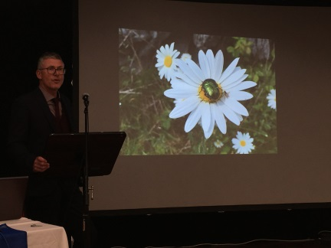
Dr Andy Bleasdale, from the Scientific Unit of the National Parks and Wildlife Service, gave a presentation on the islands both from a policy perspective but also from his own personal experience. This spanned his time as a young Irish language student on Inis Oírr, to engaging with farmers as a postgraduate student and continued through his ongoing engagement with the island as his family grew up. This set the context for his talk and indeed for the AranLIFE project, for whilst the project was about working with priority habitats on land designated as Special Areas of Conservation and /or Special Protection Areas, there is a much wider context, i.e. that the biodiversity, the culture, the language, past and present farming and practices are all part of “the story”. His thesis was that people and place should be central in any policy context.
He talked about the different habitats on the island, Pábháil Aolchloiche (limestone pavement), Féarach cailcreach (calcareous grassland) and Machaire (machair) and highlighted the flora and fauna associated with these habitats and how many of the agricultural practices required to maintain these habitats were changing, which creates challenges for maintaining or improving their conservation status. While designations are static, management needs to evolve to meet changing circumstances and people.
He saw projects like AranLIFE as a great help in linking policy and practice. He had been involved with the project from the very beginning and he could see why the project was successful. From the beginning, the project embraced the views of all the different shareholders, through discussion and debate and action, which continued throughout its duration. Working together was a central theme of the project and hopefully this type of approach can be developed in other areas.
(Translated from Irish)
Presentation: Annex 7.3.8.9 E5 reflections of NPWS_Andy Bleasdale
Day Two : Farm Visits
In the morning conference delegates had the opportunity to visit one of the participant farms and view the farming system, habitats and work completed during the project. Participant farmers also were present on the walks to answer any queries about the project.
Farm Visit 1: The Cliff Walk
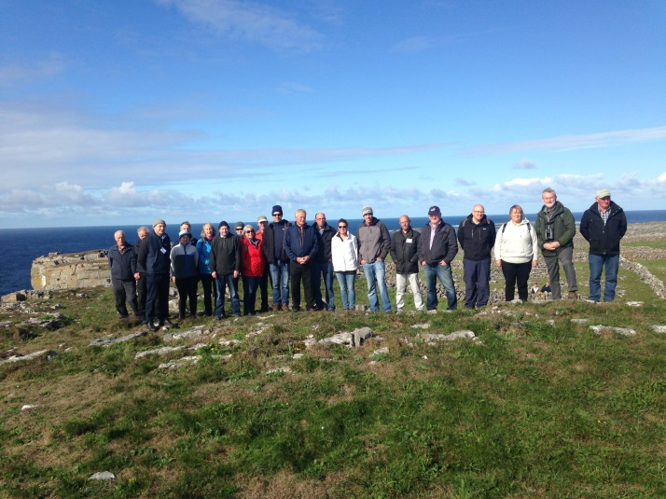
This walk was to the west of the island on the farm of Pauraic Dirrane. Pauraic’s farm is nearly all within the SAC and is composed of Limestone Pavement and Calcareous grasslands and mosaics of the two. Under AranLIFE he cleared areas of scrub, constructed and repaired a number of raincatchers and increased grazing on some areas to improve habitat condition. The farm runs to the sea cliffs, part of which collapsed in the last year.

Farm Visit 2: The Boreen Walk
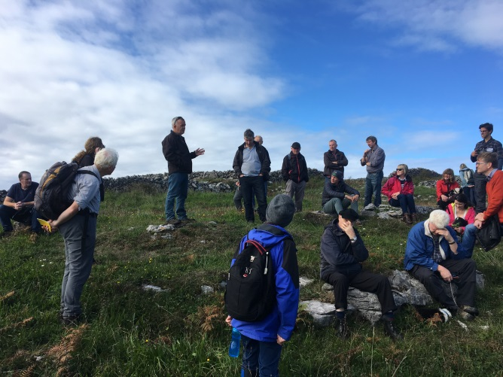
This was a visit to two farms in the centre of the island, farmed by Míchéal Ó Conghaile and Cyril Ó Flaitheartha, both of whom completed a range of works within the AranLIFE project including, improvements in access, scrub clearance, construction of new and repair of broken raincatchers and targeted grazing. Both these farms are highly fragmented, with the different land parcels connected by a series of boreens (narrow laneways), which were cleared under AranLIFE and gates strategically placed to enable grazing of the boreen which will help keep them clear.

Farm Visit 3: The Machair Walk
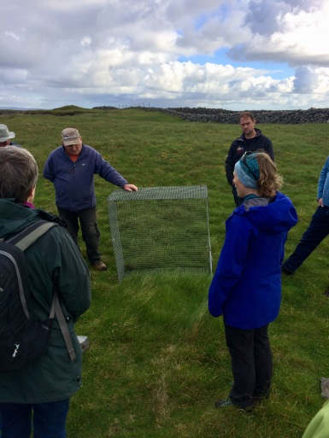
This was a visit to the farm of Pádraic Ó Flaibhearta. Located in the east of the island it contains Machair, Limestone Pavement and Calcareous grassland and mosaics of the latter two. The delegates visited the different habitats and looked at the different actions undertaken which include applications of seaweed on the Machair, rabbit control, scrub removal, provision and reconstruction of raincatchers and additional grazing.

Dr Míchéal Ó Briain: An EU Perspective
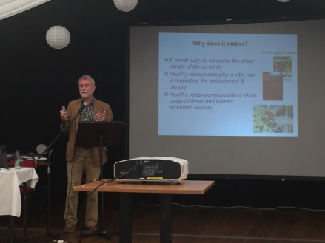
Dr Míchéal Ó Briain, Nature Unit, DG Environment, gave a presentation on the EU perspective on farming for nature. He described some of the conservation issues within Europe, giving the example of the decline of the Curlew in Ireland. He then spoke of the importance of nature conservation from a moral duty and also the role of healthy ecosystems in regulating the environment and climate and the direct and indirect economic benefits. Dr Ó Briain described the EU directives dealing with nature conservation with their objective being to achieve healthy thriving species populations and habitats and to ensure long term survival. These include the Natura 2000 sites made up of Special Protection Areas (SPA) and Special Areas of Conservation (SAC). The key principles of Natura 2000 are that sites are selected exclusively on scientific grounds, have strong legal protection, are not nature reserves but managed in collaboration with land owners and users. New activities or development are not automatically excluded but require appropriate assessments. Within Europe there are 27 758 sites totalling 1 322 630 km² which is just over 18% of the European land area and approximately 9% of the seas with the EU. An interesting point is 40% of Natura 2000 land area is farmland, highlighting the important role farming has in maintain and enhancing Europe’s nature capital.
There is a recognised need for funding to maintain these areas and there are different EU funds to support management including the Common Agricultural Policy (esp. Rural Development) and the LIFE fund, which co-funded 75% of the costs of the AranLIFE project. Within agri-environment measures there is also increasing interest in result-based payments for farming and nature which are being tested in Ireland and other Member States.
Dr Ó Briain detailed the LIFE program and how it supports best practice and demonstration allowing practical actions like those seen on the field trips within the conference. The next LIFE programme will have an enhanced budget will have strong synergies with other funds e.g. in the new CAP, possibility for Member States to use a percentage of Rural Development funding to leverage support and upscale Strategic Nature Projects.
In summary Dr Ó Briain said Natura 2000 is an opportunity for farming but will only work if real partnership with farmers are established. There is a deed for targeted actions, with good ecological advice, locally adapted to demonstrate what works in practice and the Result Based approaches could be beneficial to areas. He stated that initiatives such as AranLIFE are really important – but always need follow up continuity and it was good to see the proposed plans on the islands after AranLIFE. He talked about the new CAP proposals and it was important to get involved in the discussions to get the best outcome for farming and nature. (Translated from Irish)
Presentation: Annex 7.3.8.10 E5 EU perspective_Míchéal O’Briain
Gwyn Jones: Learning lessons for future policy
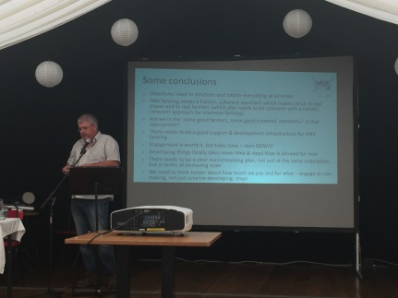
Gwyn Jones from the European Forum for Nature Conservation and Pastoralism gave a talk on learning lessons for future policy. He started by quoting Engel’s Law that as income rises, the proportion of income spent on food falls – this is the backdrop to all discussions on farm support and seems to imply that support is required for most or all farms. But that gives power to the taxpayer, who has a right to determine the conditions or outputs required. This applies equally to the intensive, supposedly ‘commercial’, sectors, which is very important since it is those types of farms which dominate the market and lobby for the regulatory framework within which both they and High Nature Value farming operate (and which currently makes HNV farming uncompetitive).
So a new approach is required, one which takes a holistic view and uses a range of complementary measures to deliver results for society – single simple measures can’t be expected to deliver well on multiple objectives. Payments for eco-systems services, including using outcome based payments from the State, are a key element in such an approach, but not the only ones. Developing and implementing these approaches takes time and a willingness to participate (and to fail). Key challenges include working through payment rationales and avoiding unintended consequences from any change in how support is delivered; place-based modelling and field testing are essential elements of ‘keeping it real’. Extending current pilots to other areas or species/habitats etc. sets a range of not inconsiderable challenges; extending the approach to other policy objectives (water quality, flood control, carbon capture….) requires a lot of development and coordination; extending it to all farms is something whose difficulties have hardly been considered.
There is usually a limit to personnel capacity and there are constraints in the knowledge base, trialling and engagement. Within the policy development process, time is a key ingredient – the time to start is now.
The present EIP process is a step forward but the link to innovation can become a constraint on its own. It is also a very piece meal approach when there needs to be a clear main stream plan so approaches can be taken at an increased level. Some knowledge already exists; Results Based Agri-environment Programmes have been trialled and are very clear in the outputs required.
Presentation: Annex 7.3.8.11 E5 Learning Lessons Future Policy_Gwyn Jones

Margaret Murray DAFM, The Irish Approach
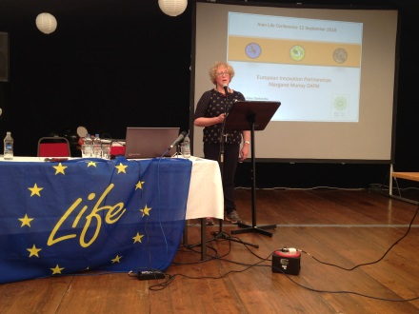
Margaret Murray from Department of Agriculture, Food and Marine (DAFM) spoke on current Irish Policy in agri-environment programmes. Agri-environments schemes have been an important part of the Rural Development Plan. REPS started in 1994 and took a whole farm approach. This was followed by AEOS in 2010 which had an environmental action based approach and was followed by GLAS in 2015 with a targeted environmental assets and action approach. More recently European Innovation Partnerships (EIP) have been used for specific environmental issues, trialling innovative approaches through partnership. Two specific themed ones are presently running, the Pearl Mussel EIP (€10 million) and the Hen Harrier EIP (€25 million). In addition there have been two open calls, €4 million for general themes and €20 million for environmental themes. The latter focused on Rural Development priorities 4, restoring, preserving and enhancing ecosystems and 5, resource-efficient, climate-resilient economy. The call is a competitive approach with a two stage selection procedure. The first shortlisted projects produce a detailed project plan, the costs of which are funded under the RDP. These plans are assessed by a selection committee and scored and a final selection is made. The first open call generated 118 ideas with 22 to proceed to funded project-plan stage and 12 were chosen for implementation. The second open call generated 68 ideas. 19 are selected to next stage and final selection will be made shortly. Caomhnú Árann, a project following AranLIFE was one of the successful projects in the first call. DAFM are now working with the successful groups to help implement the plans. Some of the issues for EIPs are that the themed ones; Freshwater Pearl Mussel and Hen Harrier EIP are big, encompassing large areas of land and large numbers of farmers. So they can be challenging to deliver whilst maintaining local identity and ownership. The open call ones are smaller and the hope is the results from these approaches can feed into future RDPs.
Whilst the EIP is new to DAFM, it is not the first experience in dealing with locally led programmes. DAFM have been involved in successful programmes like the Burren Programme, Results Based Agri-environment Programmes (RBAPS), the Hen Harrier programme and of course AranLIFE as DAFM are one of the co-funders. DAFM see more learning opportunities in the present EIP projects and are willing to listen and respond.
Presentation: 7.3.8.12 E5 AranLIFE Irish Approach_Margaret Murray

Conference Delegates
 | Name | Surname | Organisation
1 | Olive | Alcock | National Monuments Service
2 | Penny | Bartlett | NPWS
3 | Andy | Bleasdale | NPWS
4 | Debbie | Brown | NIEA
5 | Amanda | Browne | AranLIFE
6 | Thomas | Burke | Burren Farmer
7 | Hugh | Carey | National Monuments Service
8 | Pádraig | Cronin | KerryLIFE
9 | Sorcha | de Brúch | DCHG
10 | Edel | de Paor | Ateangaire
11 | Eileen | Delaney | DAFM
12 | Hannah | Denniston | DAFM
13 | Louise | Duignan | Teagasc Walsh Fellowship
14 | Brendan | Dunford | Burren
15 | John | Finn | Teagasc
16 | Mary Catherine | Gallagher | Pearl Mussel Project
17 | Seamus | Hassett | NPWS
18 | Terence | Henry | DAERA
19 | Gwyn | Jones | EFNCP
20 | Ivan | Kelly | Teagasc
21 | Mark | Kingston | DAERA
22 | Giles | Knight | Ulster Wildlife Trust
23 | Mary | Lavelle | Comhar na nOileán
24 | Jack | Lovell
25 | Angela | Lovell
26 | Deirdre | Lynn | NPWS
27 | John | Lynn | DAERA
28 | Steve | Lynott | KerryLIFE
29 | Aodhán | Mac Cormaic | DCHG
30 | Seán | Mac Eoin | DCHG
31 | Ronan | Mac Giollapharaic | Inis Mór
32 | Conor | MacThaidhg | Comhar na nOileán
33 | Caitriona | Maher | EFNCP
34 | John | Marrinan | Burren
35 | Jim | McAdam | AFBI
36 | Geraldine | McAdam
37 | Chris | McCarney
38 | Patrick | McGurn | AranLIFE
39 | Niamh | McGurn | AranLIFE
40 | Patrick Óg | McGurn | AranLIFE
41 | Bernard | McKay | Farmer
42 | Derek | McLoughlin | Pearl Mussel Project
43 | Allan | Mee | IRD Dulhallow
44 | Enda | Mooney | NPWS
45 | Margaret | Murray | DAFM
46 | Gráinne | Ní Chonghaile | AranLIFE
47 | Pádraig | Ó Fearchair
48 | Daire | Ó hUallacháin | Teagasc
49 | Ciarán | O Keefe | NPWS
50 | Cliona | O’Brien | NPWS
51 | Míchéal | O'Briain | DG ENV EC
52 | Richard | O'Callaghan | KerryLIFE
53 | Mick | O'Connell
54 | Richard | O'Donnell | Burren
55 | Barry | O'Donoghue | NPWS
56 | Eileen | O'Rourke | UCC
57 | Lorcan | O'Toole | Golden Eagle Trust
58 | Melina | Quinn | NIEA
59 | Vinny | Smith | DAERA
60 | John | Spink | Teagasc
61 | Denis | Strong | NPWS
62 | Mary | Uí Bhriain
63 | Máire Bn | Uí Chonghaile | Inis Mór
64 | Thomas | Van Rensberg | NUIG
65 | Stephen | Ward
66 | Morgan |  | Teicneoir
67 | Thomas | Conneely | AranLIFE
68 | Maureen | Conneely | AranLIFE
69 | Tom | Conneely | AranLIFE
70 | Cathal | Conneely | AranLIFE
71 | John J | Conneely | AranLIFE
72 | Peter | Conneely | AranLIFE
73 | Patrick | Conneely Stephen | AranLIFE
74 | Mary | Curran | AranLIFE
75 | Pádraic | Dirrane | AranLIFE
76 | Norah | Dirrane | AranLIFE
77 | Mary Ann | Dirrane | AranLIFE
78 | Seán | Dirrane | AranLIFE
79 | Margaret | Dirrane | AranLIFE
80 | Macdara | Dirrane | AranLIFE
81 | Owen | Dirrane | AranLIFE
82 | Maureen | Dirrane | AranLIFE
83 | Michael | Early | AranLIFE
84 | John | Faherty | AranLIFE
85 | Mary | Faherty | AranLIFE
86 | Patrick Oliver | Faherty | AranLIFE
87 | A | Faherty | AranLIFE
88 | Geraldine | Faherty | AranLIFE
89 | Michael | Folan | AranLIFE
90 | Billy | Gillan | AranLIFE
91 | Dónal | Hernon | AranLIFE
92 | Thomas | Hernon | AranLIFE
93 | Stephen | Hernon | AranLIFE
94 | Pádraig | Hernon | AranLIFE
95 | Christina | Hernon | AranLIFE
96 | Pádraic C | Hernon | AranLIFE
97 | Treasa | Joyce | AranLIFE
98 | Bertie | Joyce | AranLIFE
99 | Seán | Mac Giolla Phádraig | AranLIFE
100 | Dara | Molloy | Inis Mór
101 | Máire | Ní Chonghaile | AranLIFE
102 | Barbara | Ní hIarnáin | AranLIFE
103 | Avril | Ní Shearcaigh | AranLIFE
104 | Páraic | Ó Coincheanainn | AranLIFE
105 | Máirtín | Ó Coisdealbha | AranLIFE
106 | Míchéal | Ó Conghaile | AranLIFE
107 | Michael F | Ó Conghaile | AranLIFE
108 | Tomás | Ó Conghaile | AranLIFE
109 | Ruairí | Ó Conghaile | AranLIFE
110 | Míchéal | Ó Direáin | AranLIFE
111 | Seán | Ó Domhnaill | AranLIFE
112 | Éinne | Ó Fatharta | AranLIFE
113 | Ciarán | Ó Fathárta | AranLIFE
114 | Gearóid | Ó Flaithearta | AranLIFE
115 | Domhnall | Ó Flaithearta | AranLIFE
116 | Pádraic | Ó Flaithearta | AranLIFE
117 | Micheál | Ó Flatharta | AranLIFE
118 | Máirtín | Ó Flatharta | AranLIFE
119 | Cian | Ó hIarnáin | AranLIFE
120 | Peadar | Ó Meachair | AranLIFE
121 | Micheál | Ó Muilbhigh | AranLIFE
122 | John | O'Toole | AranLIFE
123 | Maureen | O'Toole | AranLIFE
124 | Colm | Seoighe | AranLIFE
125 | Áine | Seoighe | AranLIFE
126 | Catherine | Uí Chonghaile | AranLIFE
127 | Norah | Uí Fhlaithearta | AranLIFE

