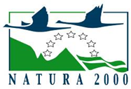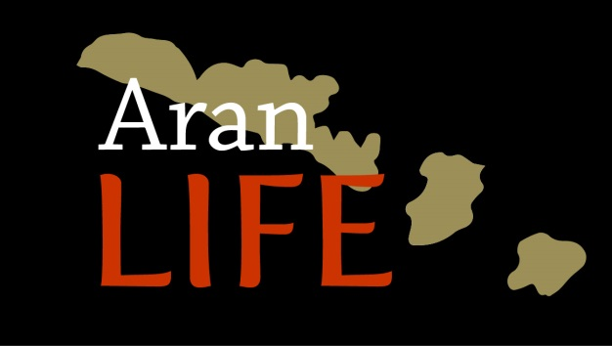

7.3.30 Recommendations on Habitat Assessment Protocols

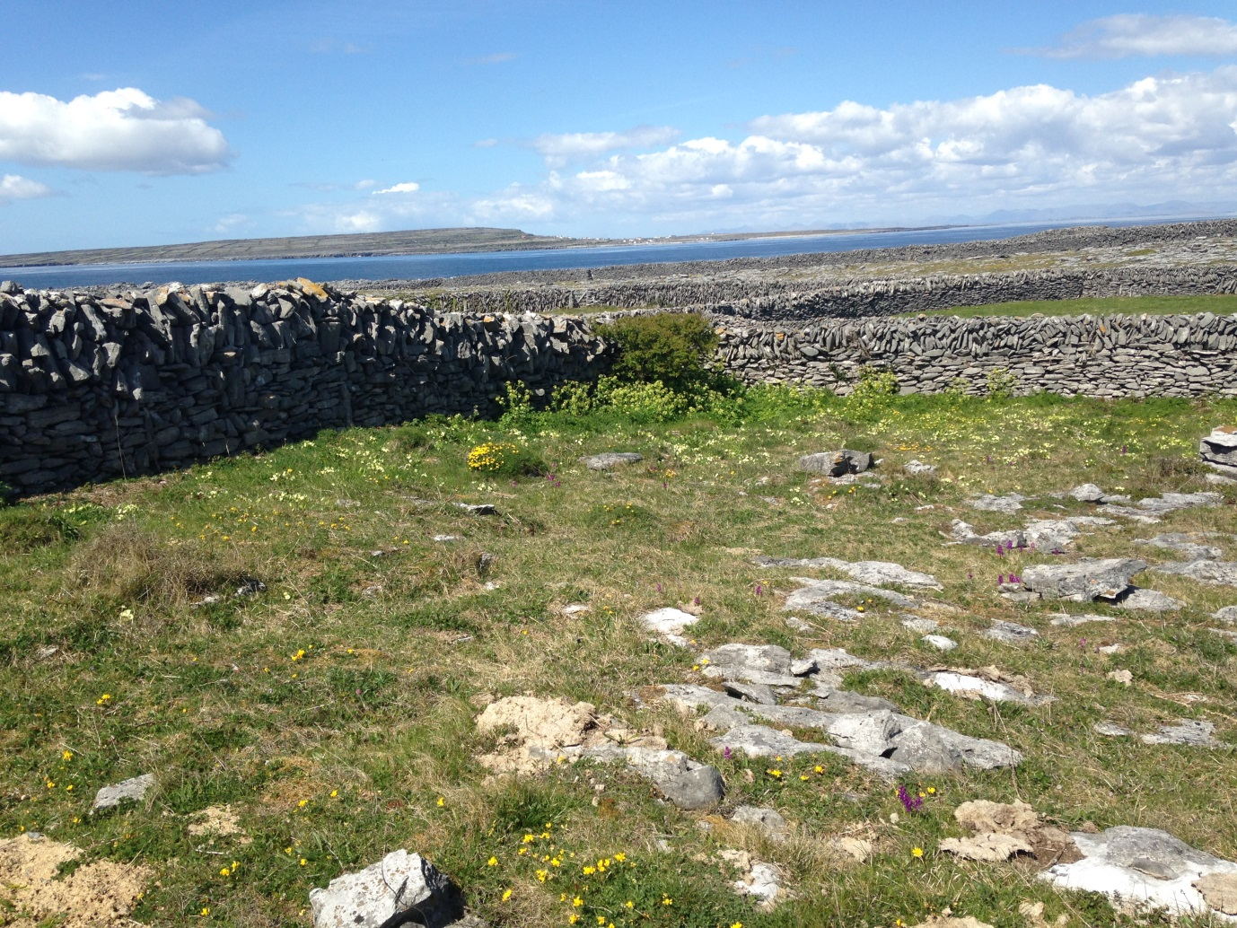

Introduction
The EU Directive on the Conservation of Habitats, Flora and Fauna (92/43/EEC), commonly known
as “the Habitats Directive”, was adopted in 1992, came into force in 1994 and was transposed into
Irish law in 1997. The main aim of the Habitats Directive is to contribute towards the conservation
of biodiversity by requiring Member States to take measures to maintain or restore natural habitats and wild species listed on the Annexes to the Directive at a favourable conservation status. Under Article 11 of the Directive, each member state is obliged to undertake surveillance of the conservation status of the natural habitats and species in the Annexes and under Article 17, to report to the European Commission every six years on their status and on the implementation of the measures taken under the Directive (NPWS 2013).

The conservation status of a habitat is defined in Article 1 of the Directive as the sum of the influences acting on a natural habitat and its typical species that may affect its long-term natural distribution, structure and functions as well as the long-term survival of its typical species. The conservation status of a natural habitat will be taken as favourable when:

- its natural range and areas it covers within that range are stable or increasing, and
- the specific structure and functions which are necessary for its long-term maintenance exist and are likely to continue to exist for the foreseeable future, and
- the conservation status of its typical species is favourable.

For habitats, the assessment of structures and functions includes an assessment of the condition and the typical species that characterise the habitat. (NPWS 2013). factors, including forb : graminoid, positive indicator species, negative indicator species, scrub and bracken encroachment, sward height, litter cover, extent of bare ground, and grazing and disturbance levels. Thresholds for each of these values for 6210 Semi-natural dry grasslands & scrub facies on calcareous substrates (FestucoBrometalia) are detailed below (O’Neill et al. 2013).

6210 Semi-natural dry grasslands & scrub facies on calcareous substrates (FestucoBrometalia) (*important orchid sites)

Criteria Scale of assessment
Vegetation composition
1 Total number of positive indicator species present ≥ 7 Relevé
2 Number of high quality species present ≥ 2 Relevé
3 Cover of non-native species ≤ 1% Relevé
4 Cover of the following negative indicator species:
Arrhenatherum elatius, Cirsium arvense, Cirsium vulgare,
Dactylis glomerata, Lolium perenne, Rumex crispus,
Rumex obtusifolius, Senecio jacobaea, Trifolium repens,
Urtica dioica, individually ≤ 10% Relevé
5 Cover of the above negative indicator species collectively ≤ 20% Relevé
6 Cover of scrub, bracken, heath
(woody species except Juniperus communis, Rosa spinosissima,
Dryas octopetala and Helianthemum oelandicum) † ≤ 5% Relevé
Vegetation structure
7 Forb component of forb : graminoid ratio 40-90% Relevé
8 Proportion of the sward between 5-40 cm tall ≥ 30% Relevé
9 Litter cover ≤ 25% Relevé
Physical structure
10 Cover of bare soil ≤ 10% Relevé
11 Area of the habitat showing signs of serious
grazing or disturbance < 20 m2 Local vicinity

Positive Indicator Species
Arabis hirsute, Brachypodium pinnatum, Bromopsis erecta, Carex flacca, Ctenidium molluscum, Daucus carota, Galium verum, Helictotrichon pubescens, Homalothecium lutescens, Leontodon hispidus / Leontodon saxatilis, (count Leontodon spp. as one), Lotus corniculatus, Origanum vulgare, Pilosella officinarum, Ranunculus bulbosus, Sesleria caerulea, Thymus polytrichus, Trisetum flavescens.
High Quality Positive Indicator Species
Antennaria dioica, Anthyllis vulneraria, Asperula cynanchica, Blackstonia perfoliata, Briza media, Campanula rotundifolia, Carex caryophyllea, Carlina vulgaris, Centaurea scabiosa, Filipendula vulgaris, Gentiana verna, Gentianella amarella/campestris, Geranium sanguineum, Knautia arvensis, Koeleria macrantha, Linum catharticum, Primula veris, Sanguisorba minor.
Orchid species (count individual orchid species separately)
† If J. communis, R. spinosissima or D. octopetala exceed 25% cover, transition to another Annex I
community should be considered, e.g., 5130 Juniperus communis formations on heaths or
calcareous grasslands, 4030 European dry heaths, 4060 Alpine and Boreal heaths.
If the 6210 grassland has a population of any orchid species other than the relatively common
Dactylorhiza fuchsii and Dactylorhiza maculata it should be considered for the orchid-rich priority
habitat *6210. The following uncommon orchid species have been recorded in this Annex I habitat:
Anacamptis pyramidalis, Coeloglossum viride, Dactylorhiza fuchsii v. okellyi, Epipactis palustris,
Gymnadenia conopsea, Listera ovata, Neotinea maculata, Ophrys apifera, Ophrys insectifera, Orchis
mascula, Orchis morio, Platanthera bifolia, Platanthera chlorantha.

6210* grasslands on the Aran Islands
Calcareous grassland habitat comprises species-rich plant communities found on shallow well-drained calcareous substrates often in association with limestone pavement and out cropping limestone rock. The habitat comprises a mixture of grasses and herbs, with calcicole species typically frequent. It is maintained by low intensity grazing but the management of calcareous grassland can vary from area to area and farm to farm. Three main areas of calcareous grassland within Ireland have traditionally been managed differently. The Aran Islands, with its collection of small fields is grazed during the winter (winterage) on a rotational basis, with cattle moved from field to field once the vegetation is eaten. The Burren also operates the winterage system but the wide open fields are managed using set stocking. Whilst the limestone grasslands in the north of the country on the Cavan/Fermanagh border are traditional summer grazed or grazed all year round on a set stocking basis. This different management will result in variations in target assessments and may require specific targets which reflect the management or cultural history of the sites as the continuation of the management system is usually favourable.
Based on survey work completed during the AranLIFE project (2014-2018), the existing thresholds used in the assessment of structures and functions for 6210* Semi-natural dry grasslands & scrub facies on calcareous substrates (FestucoBrometalia) are generable suitable but changes should be considered for point 1 (positive indicator species), 2 (negative indicator species) and point 6 (Cover of scrub, bracken).
Positive Indicators species
Following analysis the vegetation analysis of well managed areas of calcareous grassland, an additional set of positive indicator species were regularly found in high quality fields and absent from fields that were more semi-natural in character (Table 1). These species should be included in the list of Positive Indicator species.
Agrimonia_eupatoria | Hemp agrimony
Euphrasia_officinalis_agg | Eyebright
Plantago_maritima | Sea plantain
Polygala_vulgaris | Common milkwort
Rhinanthus_minor | Yellow rattle
Succisa_pratensis | Devil’s bit scabious
Calluna_vulgaris | Ling heather

Table 1. List of additional positive indicator species that are consistently found in grasslands of high conservation value in the context of the Aran Islands.
Negative indicator species
Some plant species will be present due to the management system and changing in the management system may have a negative effect of other species. Cocks foot grass Dactylis glomerata is listed as a negative species but on the islands it was found present in both high and poor quality plots but with increasing frequency on ecologically poorer plots. Dactylis glomerata is an important component of Winterage fodder as it exhibits autumnal growth (Beddows 1959). By being listed as a negative indicator species in the national assessment criteria, it gives the impression that this is an unwanted species in calcareous grasslands, as it is an indicator of the management, which is necessary to maintain the overall species composition.
Cover of scrub, bracken.
Under national assessment criteria, the thresholds for cover of woody species are ≤ 5% at the relevé assessment. The management practices and the farm structure all favour the growth of scrub. Crofts and Jefferson (1999) found that even in grasslands of low fertility, winter-only grazing will usually still allow scrub to encroach and this is reflected on the islands where additional scrub control is required. In addition the large number of stone walls and small fields favour the germination of scrub seedlings, giving shelter from the wind and the absence of summer grazing allows them to go to the woody stage. As a result a lot of scrub is found along the walls.
Scrub invasion is considered to be an acute threat because it can result in an increase in soil nutrients and a decline of richness in grassland species but the Annex I habitat 6210 includes scrub margins within its definition (Calaciura and Spinelli, 2008). A survey of people with a high level of ecological expertise who attended an AranLIFE workshop (Annex 7.3.6) identified scrub encroachment of species-rich calcareous grassland as a major threat on the island. However an element of scrub was still deemed to be a positive feature for wildlife. General consensus was that up to 10% of the area scrubbed up was an acceptable, but greater than that the loss of species rich grasslands was problematic. A survey of invertebrate populations on the island on different habitats by Hynes (2017) showed groups of invertebrates showed a marked preference for different habitat types, some favouring scrub parcels. Pearson et al. (2006) suggested management measures should aim at keeping scrub encroachment below 20% of the total surface maintaining some scrub habitats in their own right, but retaining the balance of open grassland.
Therefore the project recommend a change from measuring scrub at the relevé assessment to a percentage cover within the field which should be below 10% of the total surface of the field.

Further information can be found in Annex 7.2.9 D.1 Habitat Management Report and Annex 7.2.10 D.2 Ecosystems Services Report.

References
Beddows, A. R., (1959). Dactylis glomerata L. (Ed. 11) No. 2169. List Br. Vasc. Pl. No. 6781 [Biological Flora of the British Isles. Journal of Ecology 47(1), 223-39.
Calaciura B., Spinelli O. (2008). Management of Natura 2000 habitats. 6210 Semi-natural dry grasslands and scrubland facies on calcareous substrates (Festuco-Brometalia) (*important orchid sites). European Commission.
Crofts A. and Jefferson R.G. (eds) (1999). The Lowland Grassland Management Handbook. 2nd edition. English Nature/The Wildlife Trusts. Royal Society for Nature Conservation.
Hynes I (2017). Contribution of habitat patches to the Invertebrate biodiversity on Inis Oírr using Rapid Biodiversity Assessment. Unpublished thesis. B Sc (Hons) in Environmental Science, NUIG.
NPWS (2013). The Status of Protected EU Habitats and Species in Ireland. Overview Volume 1. Unpublished Report, National Parks & Wildlife Services. Department of Arts, Heritage and the Gaeltacht, Dublin, Ireland. Editor: Deirdre Lynn.
O’Neill, F.H., Martin, J.R., Devaney, F.M. & Perrin, P.M. (2013). The Irish semi-natural grasslands survey 2007-2012. Irish Wildlife Manuals, No. 78. National Parks and Wildlife Service, Department ofArts, Heritage and the Gaeltacht, Ireland.
Pearson S., Schiess-Bühler C., Hedinger C., Martin M., Volkart G. (2006). Gestione di prati e pascoli secchi. Editors: Ufficio federale dell’ambiente (UFAM), Berna; AGRIDEA, Lindau, Confederazione Svizzera.

