**7.3.5 Animal Health Workshop**

**Subject: Report on Aran LIFE Animal health Workshop**

**Date: 15th December 2015**

**Workshop Theme: Animal Health on the Aran Islands**

**Venue: Co-op Inis Mór**

**Outline**

This report is based on the proceedings of a workshop held on Tuesday December 15th, 2015 in Ionad Fiontair Cholm Ó hIarnáin, Inis Mór, Co. Galway. The purpose of the workshop was to share practical information and experience on animal health and nutrition issues affecting livestock farmed on the islands and AranLIFE’s role in addressing these issues. Over the first two years of the project, the AranLIFE Project team has amassed information on management regimes, soil analysis, forage analysis and livestock blood mineral levels from a range of farms within the islands. The workshop was an opportunity to bring together people with specific expertise in the subject, record their input and develop any corrective measures to meet the needs of the grazing livestock. Attending the workshop were the AranLIFE Project team consisting of Dr Patrick McGurn, Dr Amanda Browne, Gráinne Ní Chonghaile and Louise Duignan (PhD Researcher); Dr James Moran, IT Sligo and former Scientific Officer with BurrenLIFE, Máire Connelly, the local Veterinary Surgeon for the islands, Rita Gately, Veterinary Surgeon with Galway County Council; Thomas Faherty, Chris Faherty, Bertie Joyce, Gearóid Ó Flaithearta, Domhnall Ó Flaithearta, participant farmers in the AranLIFE project and from Teagasc, Ivan Kelly, local agricultural adviser and Dr Stephen Butler, Animal and Bioscience Researcher.

The day commenced with a visit to the farm of Gearóid Ó Flaithearta, to give participants an overall view of the farming system. Gearóid explained that his farm was split into summer grazing and winter grazing. During the summer cattle grazed fresh grass on the greener fields closer to his house whilst the winterage was left to grow to produce a standing crop that was then grazed throughout the winter. Some supplementary feeding occurred during the winter but the grazed grass was the major component of their diet. Livestock type were beef cows with the calves sold at weaning (6 months), with an occasional heifer calf retained as a future cow. This is the predominant system of agriculture on the islands.

Back at Ionad Fiontair Cholm Ó hIarnáin, Dr McGurn presented a general overview of the work of the AranLIFE project. Máire Connelly then gave a synopsis of animal health on the islands. She outlined how the farmers try to operate a “closed herd”, i.e. breeding all their own replacement cattle and limiting the number of bought in cattle. This reduced the chances of bringing in disease and the islands are clear of Tuberculosis and Brucellosis. Occasionally stock bulls were purchased off the island and Máire’s advice was to vaccinate immediately for clostridrial diseases and treat the animal for parasites before joining with other stock. In general there is little problem with stomach and intestinal worms *(Ostertagia* and *Cooperia*)due to the low stocking rates and rotational grazing but hoose (*Dictyocaulus viviparous*)can be a problem if picked up from imported stock as the home bred animals have no prior immunity. Liver Fluke *(Fasciola hepatica)* is mainly restricted to sheep as they tend to graze the more marginal wet areas of the islands. Regarding external parasites, Lice can be a problem during the winter period with treatment required. The islands also have a heavy tick burden (*Ixodes ricinus*) and there have been a few cases of Lymes Disease on the islands. In general the animals are immune to Redwater (*Babesia divergens*), carried by the tick but any livestock purchased from the

mainland are most likely to show symptoms of Redwater. Whilst there are preventative treatments, Máire prefers to give the animals some time to build immunity, two weeks, prior to giving preventative treatments but farmers need to be particularly vigilant for signs of Redwater during this lag time and if possible buy livestock that are more likely to be resistant, e.g. from West Galway.

The main breeds of livestock are Shorthorn, Angus and Hereford cross and in the past these were crossed with traditional breeds, however as in the rest of Ireland there has been a move to Continental breeds such as Charolais, Limousin, and Aubrac as a terminal sire. These breeds can do well on the islands, though calving problems tend to be greater which can be problematic as a vet is not readily available.

The project team then presented the preliminary data on the feeding regimes, concentrate supplementation, soil analysis, forage quality, forage analyses (including mineral analyses); and mineral levels found in livestock blood tested through the DAFM Regional Veterinary Laboratories.

A questionnaire on 12 farms completed by Louise Duignan in some of the evaluation work found that supplementation of additional feed (other than grazed grass) occurred on most but not all farms. For beef cows this tended to be limited to the late winter/early spring period but sometimes only directly pre and post calving. Weanling calves (6 months) tended to get concentrate supplementation straight after weaning and then throughout the winter period. There was no specific feeding regime with overall additional feeding levels low (25kg per cow per winter in some cases). The use of mineral licks seemed to be common practise, some farmers including them with livestock all year around whilst others limiting them to the winter period. Some farmers give a mineral bolus to cows especially in the autumn.

**Soil Analysis**

Soil analysis results were presented from a random sample of fields throughout the islands. The pH of the samples ranged from 5.78 to 8.1 with over 93 % of the samples having a pH greater than 6.0 and over 50% having a pH over 7.0. High pH soils can cause interference on availability of P, K, Mn, B, Cu, Zn, and Fe. Teagasc soil analysis are conducted using Morgan’s Test which is recommended for acid soils and therefore may not be the best option for evaluating the analytical content of Aran Islands’ soils. To check this, samples from Machair grasslands were also sent to an alternative laboratory which used Olsen’s method developed for high pH soils. Average values with indices in brackets (using the Olsen method) for pH, Phosphorous, Potassium and Magnesium were 8.0, 4.3mg/l (0), 58mg/l (0) and 142mg/l (3) respectively. In agricultural terms this is indicative of soils with a high pH, very low Phosphorous, low Potassium and high Magnesium soils. Using Morgan’s Test average values with indices in brackets for pH, Phosphorous, Potassium and Magnesium were 8.27, 13.5mg/l, (41)1mg/l (1) and 521mg/l (3) respectively. In agricultural terms this is indicative of soils with a high pH, high Phosphorous, low Potassium and high Magnesium soils. A comparison in samples from a range of soils tested using Morgan’s Test and Olsen’s Test is shown in Appendix 1. Therefore Morgan Test is unreliable for use under the high pH soils of the Aran Islands.

**Forage Analysis**

The AranLIFE project is measuring the nutrient status of the growing forage to aid in determining any mineral and nutrient supplementation levels required during the year. Fifty sampling sites were randomly selected and forage samples taken in March, June and August 2015. The samples were analysed for oven dry matter (DM), Crude Protein (CP), Ash, Acid Detergent Fibre (ADF) and Neutral Detergent Fibre (NDF). The averages for each period and associated ranges are outlined in Table 1.

|  |  |  |  |  |  |  |  |  |  |  |
| --- | --- | --- | --- | --- | --- | --- | --- | --- | --- | --- |
| **Sample date** | **DM (%)** | **Range** | **CP (% DM)** | **Range** | **Ash (% DM)** | **Range** | **NDF (% DM)** | **Range** | **ADF (% DM)** | **Range** |
| **Mar** | **48.44** | **22-70** | **9.87** | **5.15-17.65** | **5.48** | **3.12-9.9** | **66.58** | **54-74** | **34.93** | **26-39** |
| **May/June** | **29.09** | **22-48** | **11.84** | **8.1-17.45** | **6.53** | **4-8.5** | **48.64** | **19-66** | **26.84** | **18-34** |
| **August** | **28.66** | **15-44** | **10.77** | **7.18-17.76** | **6.94** | **4.2-6.93** | **50.68** | **38-50.68** | **29.53** | **29-52** |

**Table 1:** Mean average forage quality values taken from different grassland within the islands.

There is considerable range in the variables reflecting different plant community types and the grazing patterns occurring.

The mineral content of the forage were also measured in a sub set of the samples which reflected the different community types. In general mineral levels are low in grazed forage throughout the year and without supplementation mineral deficiencies are likely particularly in Phosphorous, Copper and Cobalt and Selenium.

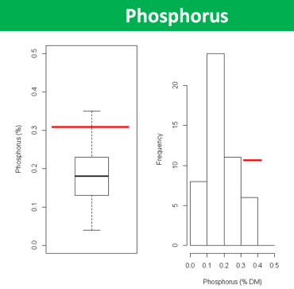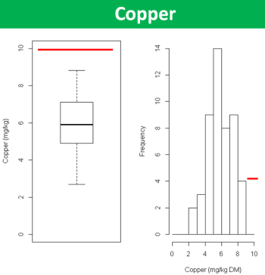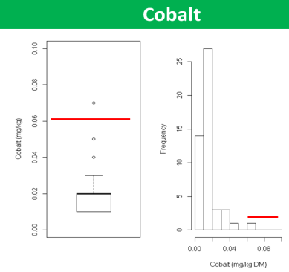

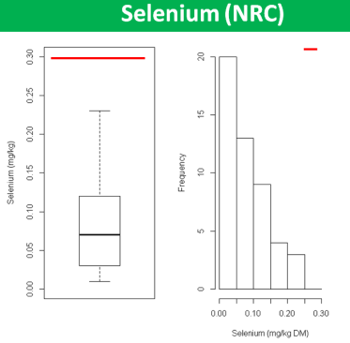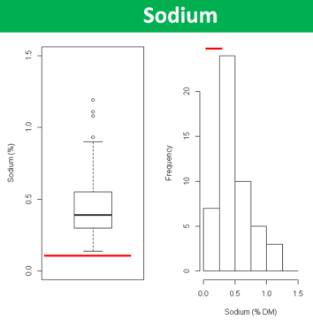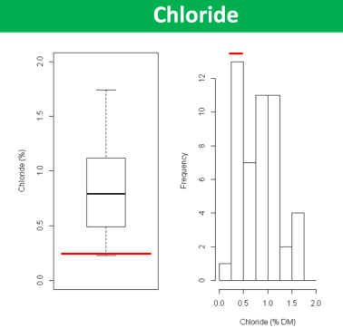

**Blood Analysis**

To determine the mineral status of livestock on farms a total of 95 animals were blood sampled and the samples analysed by the DAFM Regional Veterinary Laboratories. Only mineral levels suitable for measuring by blood sampling were tried. These included Copper, Phosphorous, Selenium (GSH-PX), Calcium and Magnesium. Calcium and Magnesium were detected in adequate quantities. Levels of Copper and Selenium indicated a deficiency problem within the overall livestock herd. The average value for Copper was 10.6 umol/l with a recommended range of 9.4-24umol/l. However 23%of 94 animals tested were below the normal range and therefore deficient in Copper. The average value of the 72 cattle tested for Selenium (GSH-PX) was 34 with a recommended range of 18.46-500units/ml PCV. However 43% of animals tested were below the recommended range and therefore deficient in Selenium.

There were some animals deficient in phosphorus, 6%of the 95 animals tested were below the recommended range of 1.4-2.4mmol/l. However the overall average was 2.47mmol/l with 48% of the livestock having higher than the recommended range for Phosphorous. Therefore despite the low levels of Phosphorous in the grazed forage and low levels of supplementation the livestock appeared to be obtaining sufficient phosphate form some source or Phosphorus depletion is not identified in the blood samples, because chronically phosphorus-depleted animals can maintain the Phosphorous concentration within normal limits by mobilizing reserves from bone.

**Cattle performance**

Daily liveweight gains of weaning calves from birth to weaning were also recorded on a number of farms. The average daily liveweight gain for 7 calves recorded on two farms was 1.14kg, with a range from 0.9kg to 1.3kg. The average weanling weight of 16 calves weighed from a number of farms was 290kg, ranging from 214kg to 370kg. The average weight of 11 cows at weaning was 624 kg ranging from 469kg to 760kg. Breeds varied from continental (Charolais, Aubrac, Simmental) to traditional breeds (Shorthorn, Angus and Hereford).

Following the presentations, a general discussion took place. The main themes explored were the implications of forage quality for animal health, general health issues on Aran farms and proposals for the next steps in developing a model of best practice for animal health and conservation farming on the Aran Islands.

**Discussion**

There are some clinical signs of mineral deficiencies on the islands and these appear to be getting more common. Some of the reasons discussed were the switch from traditional type breeds to heavier Continental breeds. The higher nutritional demands from the bigger continental type may be causing deficiencies symptoms, particularly in new born calves in the last trimester of calving, when the energy requirements of the foetus are at their highest and it corresponds with the time of the year when the nutritional quality and availability of grass is at its lowest. In addition the reduction in areas of tillage, fertilised using seaweed, means fewer minerals are being returned to the soil.

From the forage mineral analysis the trend was that forages were deficient in Phosphorous, Copper, Cobalt and Selenium and provided excess Sodium, Chloride, Iodine, Manganese and Iron. It is normal for Manganese and Iron to be provided in excess on grass based diets and is not a cause for concern, but it is not normal for Sodium, Chloride and Iodine to be so high and is likely as a result of oceanic influences. High Sodium and Chloride levels could be a concern where water availability is limited and the lack of water is an issue on many areas of the islands.

The low level of Phosphorous in the forage would suggest blood phosphorous levels should be low; however the blood sampling indicated high Phosphorous levels in most livestock. Therefore livestock must be obtaining Phosphorous elsewhere in their diet. The recommended daily level of Phosphorous for beef cow is 4.8g/day and so it is unlikely that occasional supplementation through the injection of injectable phosphorous (Phosphonortonic 20% at 10-25ml) is responsible for the high blood Phosphorous levels. Spring fed water may contain Phosphorous but at present no chemical analysis of water on the islands is available.

Regarding the feeding quality of the forage available, for analysis purposes the forages were outside the range recommended for the use of Near Infrared Reflectance Spectroscopy (NIRS) so all analysis were completed using traditional wet chemistry processes. The analysis measured Dry Matter(DM), Crude Protein(CP), Ash, Acid detergent Fibre (ADF) and Neutral Detergent Fibre (NDF). As expected, the results show that as forage maturity increased so did its dry matter and fibre content, whilst the protein content declined.  Consequently, the digestibility and feeding content of the grass is likely to decrease with maturity. ADF measures the least digestible plant components, including cellulose and lignin and its values are inversely related to digestibility, so forages with low ADF concentrations are usually higher in energy. NDF measures the total cell wall which is comprised of the ADF fraction plus hemicellulose. NDF values reflect the amount of forage the animal can consume. As NDF percent increases, the dry matter intake generally decreases. Low NDF values are desired because NDF increases as forages mature.

Although ADF and NDF are good indicators of fibre contents in forages, they do not measure how digestible that fibre is and therefore not an ideal measure to use when formulating beef cow rations. Equations to predict digestible energy (DE) and metabolizable energy (ME) used for grazing cattle have been developed with cattle fed conserved forage but they may not be suitable for forages collected in a semi-natural grassland. It is a feature of the islands that in general cows do lose condition during the winter months, a standard agricultural practice, making up weight in the grass growing season. Therefore it is unlikely that the winter grass, sometimes referred to as “foggage” in agricultural literature is sufficient to meet the cow’s requirements so supplementation will be required in conjunction with condition loss. Supplementation should be aimed at ensuring main nutrients are supplied and the loss of cow condition has no detrimental effects on future calf performance.

**Follow up steps**

* Further evaluation of the feeding value of the semi-natural grasslands
* Continue with some blood samples and possible other methods for identifying mineral deficiency (Cobalt)
* Production of booklet specific to Aran Island farms dealing with animal nutrition and cow condition scoring
* Further evaluation of mineral deficiencies, possible through following up of cull cattle, identifying reason for high blood phosphorous/low forage phosphorous
* Trial mineral supplementation on farms through:

Multi-trace element Boluses Mar 2016 to December 2017

Multi-trace element Mineral Licks Mar 2016 to December 2017

Ration Supplement Winter 2016/17

* Identify any issues with cow fertility

Appendix 1 Morgan’s Soil Test vs Olsen’s Soil Test.

